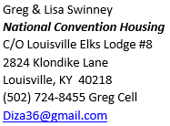
156th Grand Lodge Convention
Tampa, FL
Sunday, July 4th – Wednesday, July 7th
2021

Hope all are staying safe and healthy through these very trying times, 2020 has proven to be an extraordinary year. Due to overwhelming concerns about the coronavirus, we felt this was the best way to proceed during such unprecedented global situation. At this time, we are assigned to the Westshore Grand Hotel Tampa rates are $118 plus tax and we have a 40 room block. Self-Parking is free in the garage and we are located four miles from the Convention Center. There will be the bus shuttle service to the Convention Center. All the hotels are in the downtown area. Restaurants and shopping are open. Shula's Restaurant is not expected to be open during the convention, but there are other dining options. The Hospitality Rooms for VA, KY and MI are located on the 1st floor, adjacent the hotel lobby. The space is a hotel ballroom that will be divided into three large rooms. Plenty of room for social distancing. The KY Special Event will be on Tuesday Night July 6th dress like a pirate in the Hospitality room.

Keep in mind: If you use a debit card it may take 7 to 10 business days for the card to be credited back. All cancellations must be made to Greg Swinney. If you register and then decide not to go you need to inform Greg Swinney as soon as possible or you will be considered a no show and will be charged for one-room night deposit. Confirmations will be sent from Hotel via email at this time. This may change after our visit. The Housing Team is planning to arrive late Friday, July 3rd. The Hospitality Room should be open by 3pm Saturday.
The Opening Ceremony will be on Sunday, July 4th at the Tampa Convention Center. Time TBD. Current plans are to have a live band for entertainment following the ceremony.
With the COVID 19 situation limiting our ability to get an accurate count for attendees, Your Housing Representatives are asking everyone that is planning to attend to fill out the Convention Registration send it via Email to Greg Swinney at Diza36@gmail.com or take a picture of your filled out form and send it by text to 502-724-8455!!!
Please remember Lodge Representatives sent by their Lodge to attend the National Convention, should attend all business sessions!
When filling out the form:
RESERVATIONS MUST BE RECEIVED BY GREG SWINNEY ASAP.
Please do NOT call hotel directly to make or cancel reservations.
Convention Pre-Registration will be available April 1st visit https://www.elks.org/convention/prereg.cfm . When you register early it will save you money and make the registration process easier for the National Team this will prevent long lines to pick-up your credentials.
156th Grand Lodge Convention
Tampa, FL
Sunday, July 4th – Wednesday, July 7th

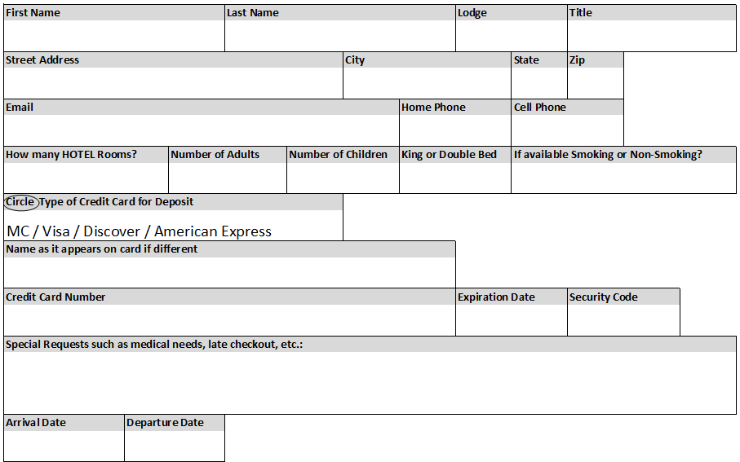
ROOM RESERVATION FORM
*This does Not register you for Convention Events
PLEASE PRINT (Email or Text form ASAP)
